**Group members names and contributions:**

* Leon Wu (301313026):
* Scenario # 1
* Implementing filter for search and sorting choice
* Arsen Nurshaikhy (301384956): Scenario # 2
* Scenario #2
* Designed my course page and
* Hansoo Yoon (301311124):
* Scenario # 3
* Implemented new add and edit features for courses
* Gaurav Gupta (301368927):
* Scenario # 4
* Implemented a feature to add notification to courses.

**Project link:**

<https://drive.google.com/file/d/1edkQBq5HOMQGG5V8bwv3h9ptwB5UA7eK/view?usp=sharing>

**Self-assessment of the design:**

Usability: 8 of 10

Usefulness: 7 of 10

Desirability: 7 of 10

**Appendix:**

* MySchedule sfu webpage: <https://myschedule.sfu.ca/>
* Facebook mobile app search bar: <https://www.facebook.com/public/Search>
* Google calendar: <https://calendar.google.com/calendar>

**Design Scenario #1: User uses search option filters**

Amy is a first-year student who just got admitted by SFU. She heard from her friend that she can build her course schedule by using the SFU mySchedule app. Since she wants to graduate on time, she needs to include some courses that satisfy the WQB requirement in her schedule. For the term 2021 spring, she wishes to have 3, 100-level courses in her schedule, and because she also has a part-time job, she wants all her courses to have 3 credits. Logging onto mySchedule app from her iPhone, she browses all courses that fit her requirement. She initially added CMPT 105W that satisfied W-designation, CA 104, and CMPT 120, but then, through discussing with friends, she heard a 100-level, Q-designation course called ECON 103 is only available this term. She then drops the CA 104 and selects PHIL 105 as a replacement. Eventually, she manages to build a schedule with no conflict.

wireframe 1:

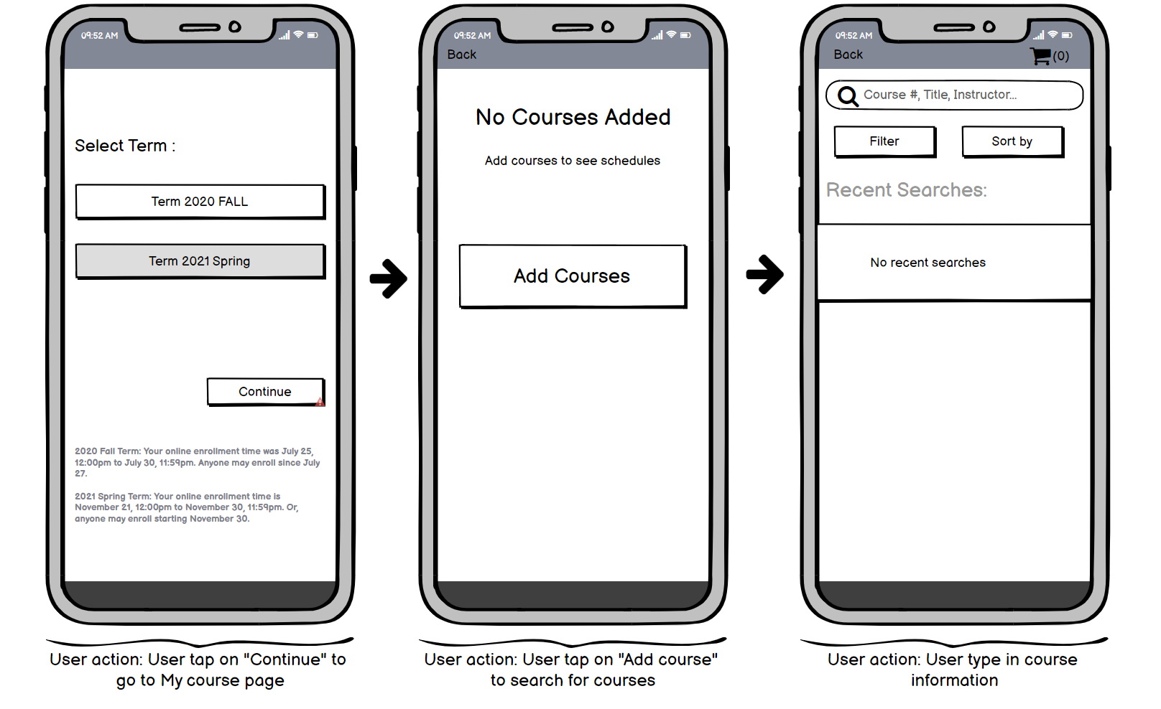

wireframe 2:

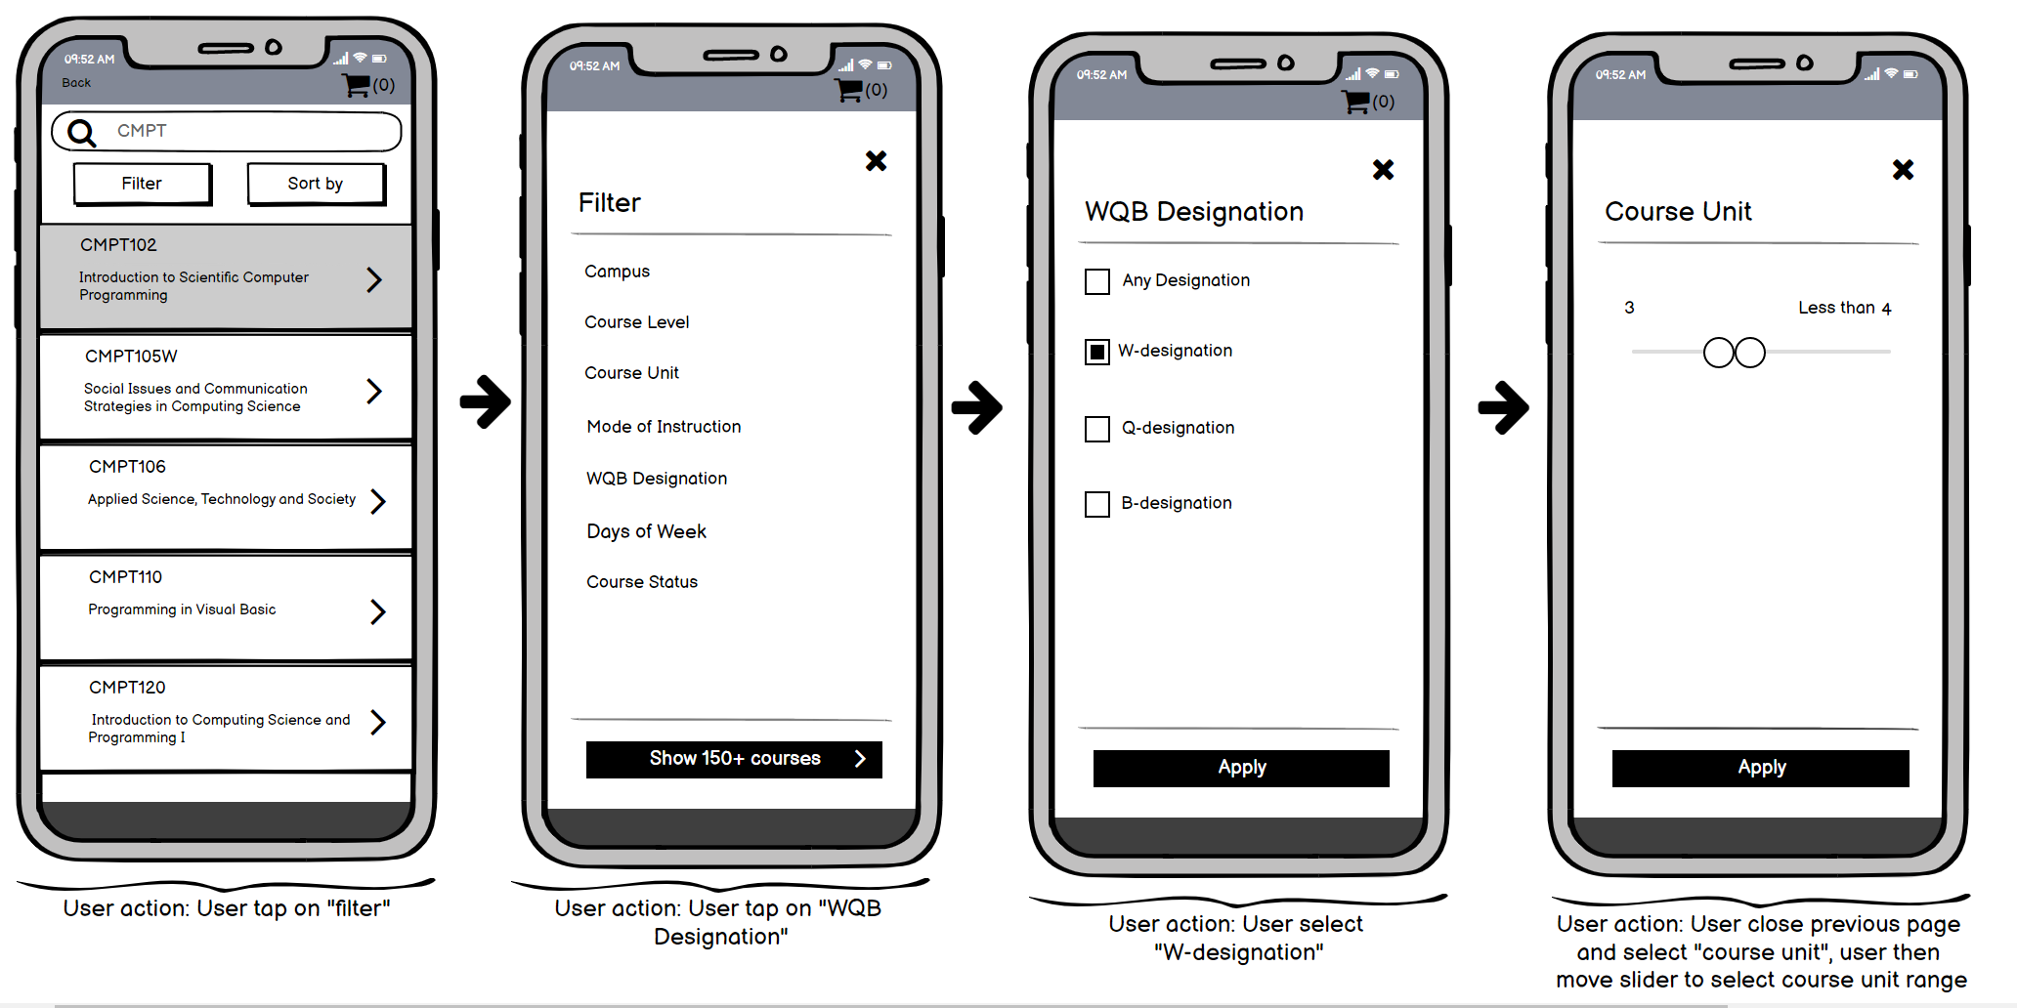

wireframe 3:

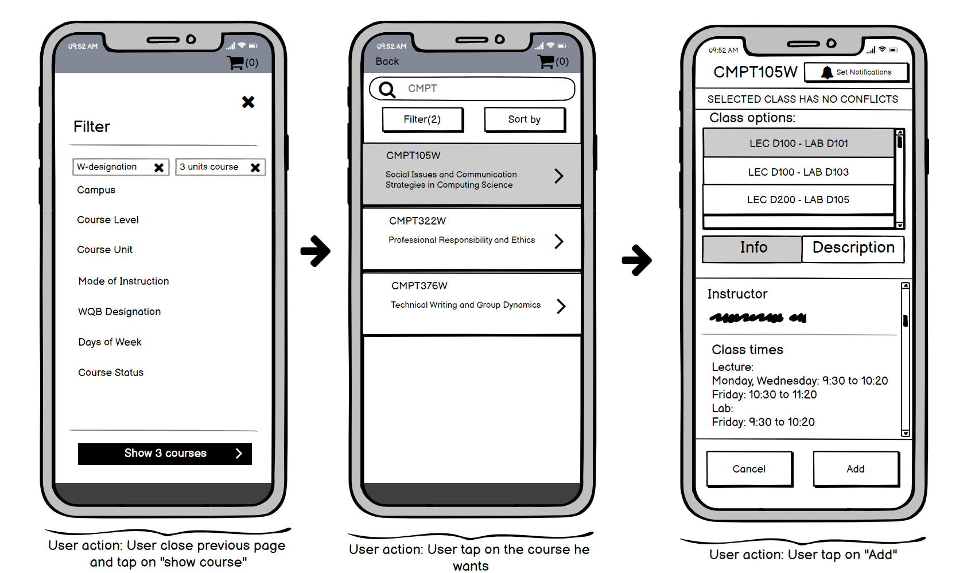

wireframe 4:

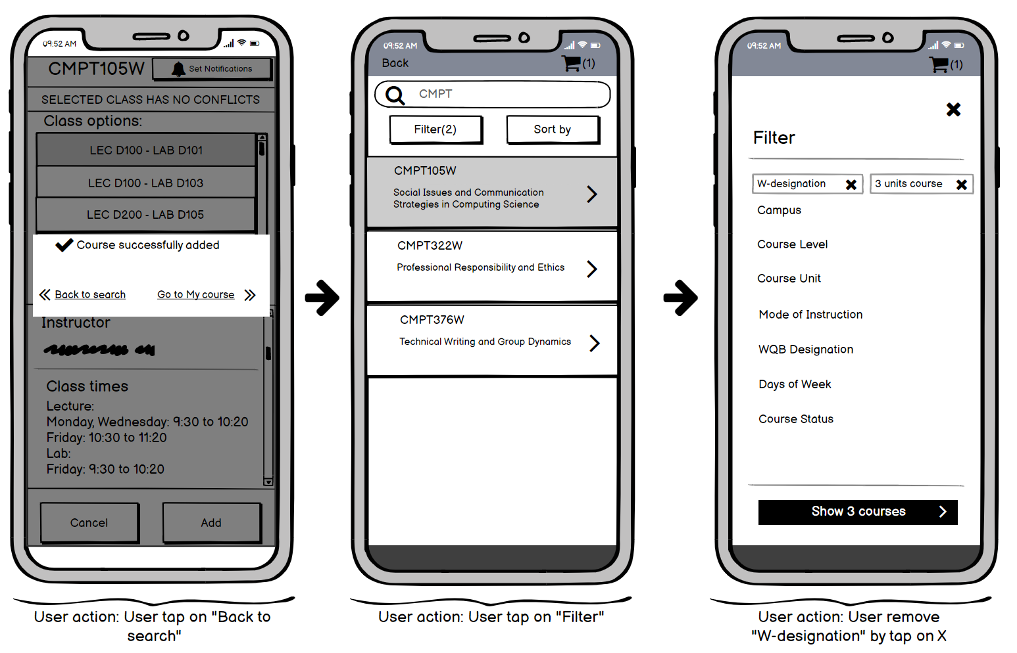

wireframe 5:

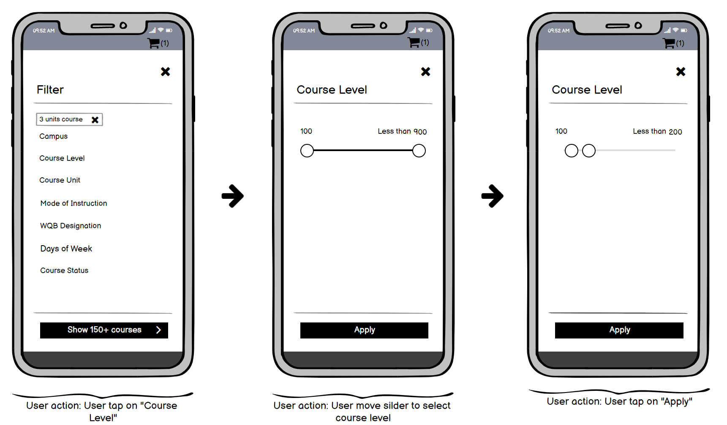

wireframe 6:

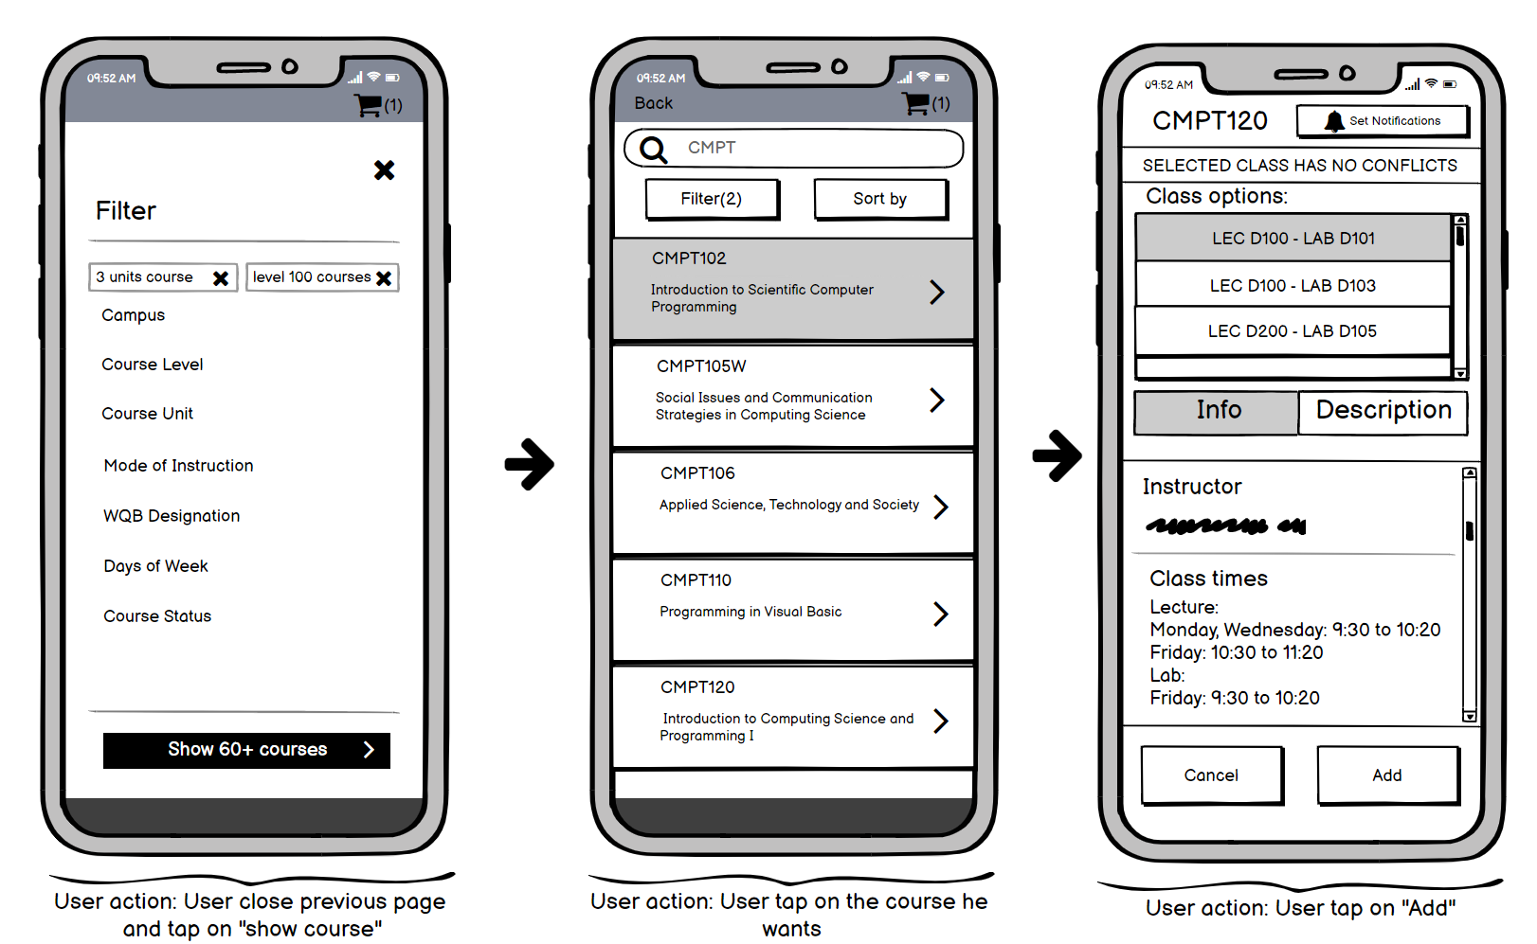

wireframe 7:

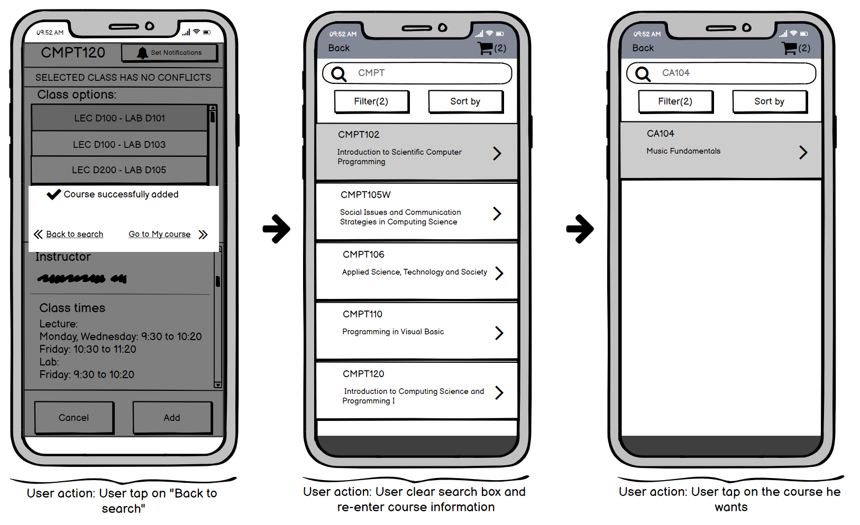

wireframe 8:

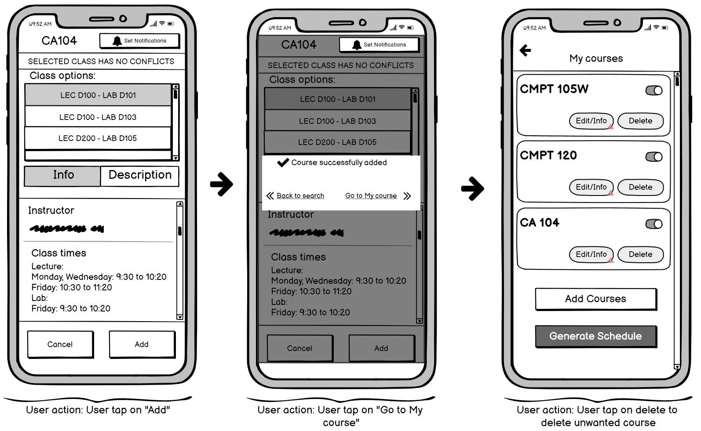

wireframe 9:

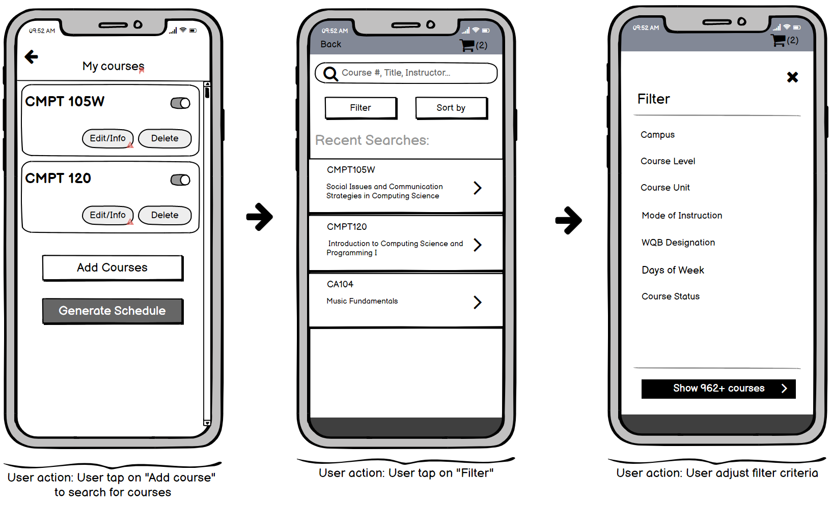

wireframe 10:

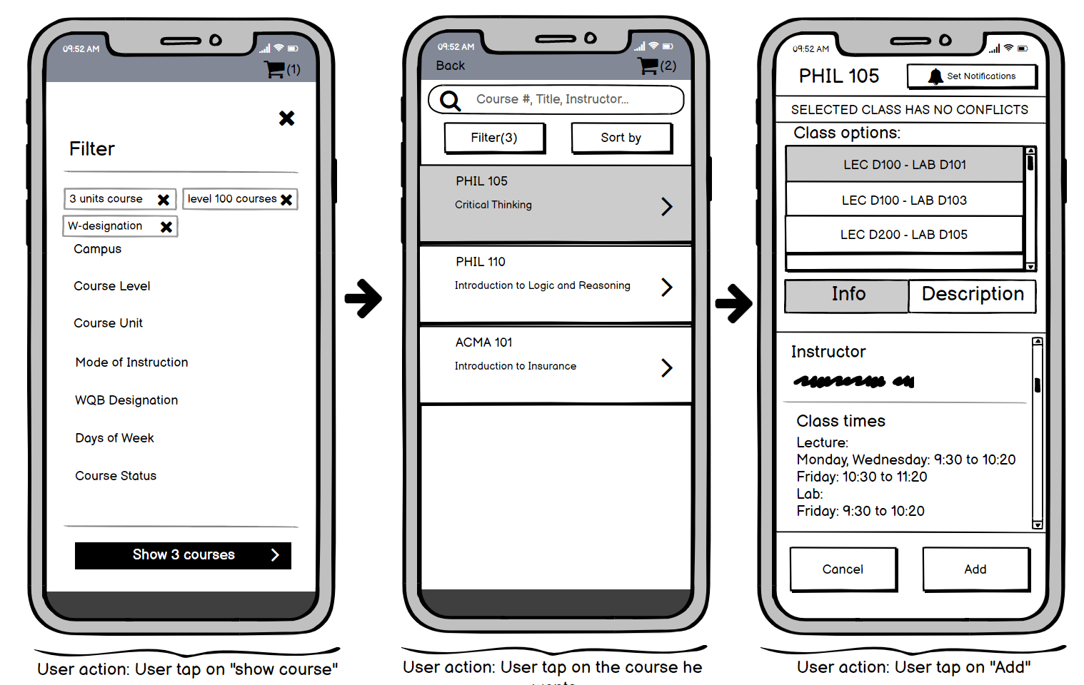

wireframe 11

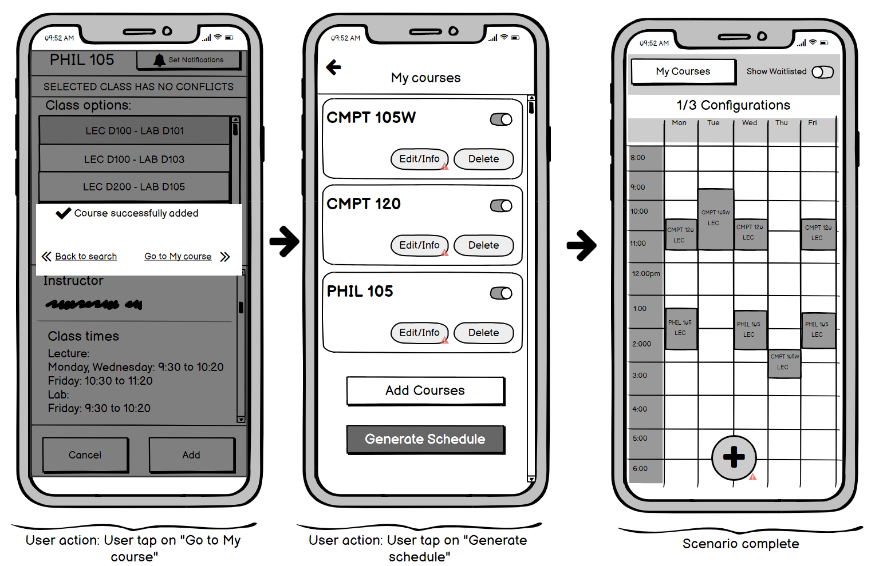:

**Design Scenario #2: User finds conflicting classes**

John Bidem is starting his second year in computer science at SFU. As he finished his first-year courses, John must take CMPT 225 as it is a prerequisite for most upper-division CMPT courses. In addition, he is planning to take two additional computer science courses to make his schedule. After the schedules for the upcoming term were released John opens his phone to have a look at the courses that he is interested in to enroll in via SFU MySchedule app.

Since his main goal is to take the CMPT 225 course next semester, he makes sure that his schedule includes a desirable section for that course no matter what other courses section times might be. Meanwhile, John has a class that starts soon and he decides to initially add MATH 232 and CMPT 295 into his schedule ignoring the fact that these courses might produce time conflicts because he wants to try different courses while planning his schedule. While making a schedule it turns out that there are time conflicts between his desirable section of CMPT 225 and CMPT 295 sections and CMPT 295 sections and MATH 232 sections. Due to the fact, CMPT 295 interferes with his two other courses John decides to remove CMPT 295 from his schedule. In an attempt to remove CMPT 295, he accidentally deletes the CMPT 225 course from his schedule due to his hurry to the lecture. He then recovers from removal so that his desirable section would be returned to a schedule. John then replaced CMPT 295 with MACM 201 that did not give him any time conflicts. Since he made an initial version of a schedule for the upcoming term he came to a class on time.

**Scenario storyboards:**

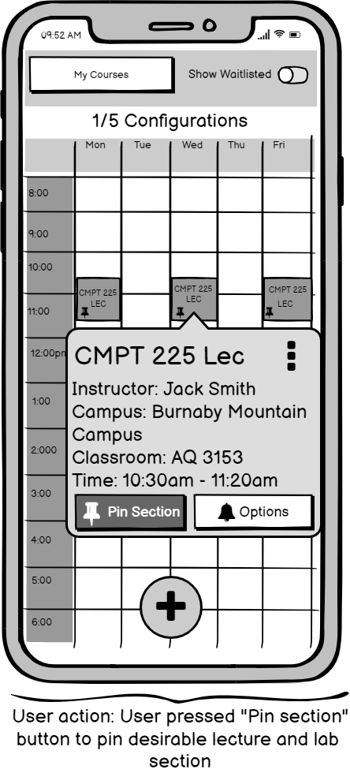  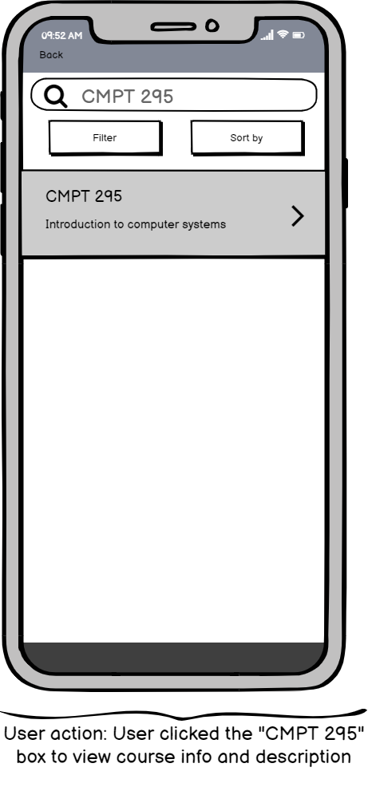

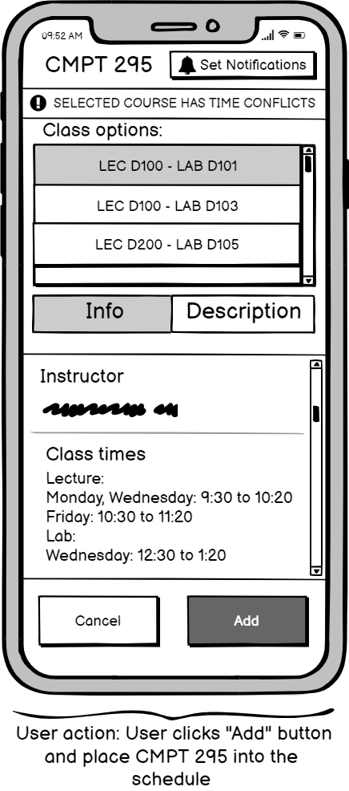  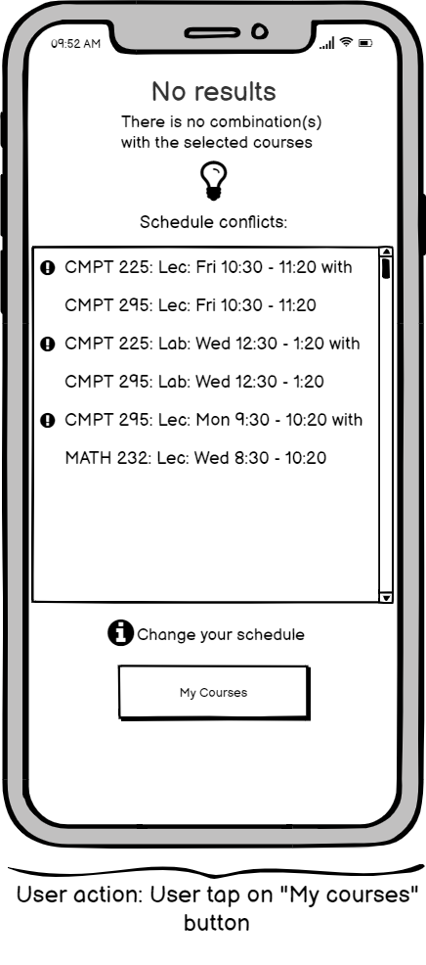

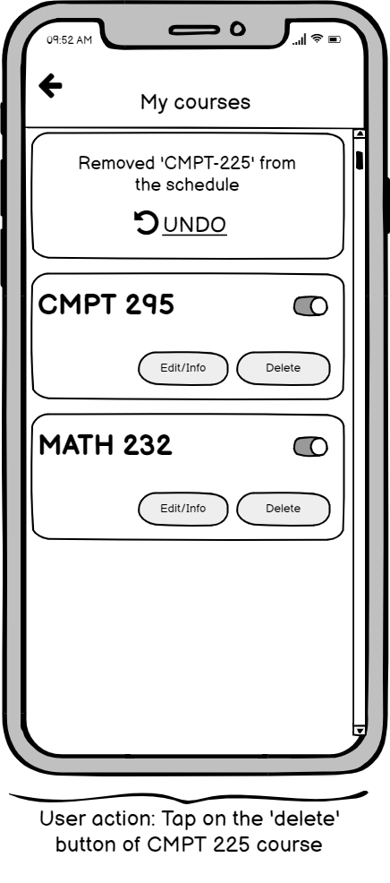 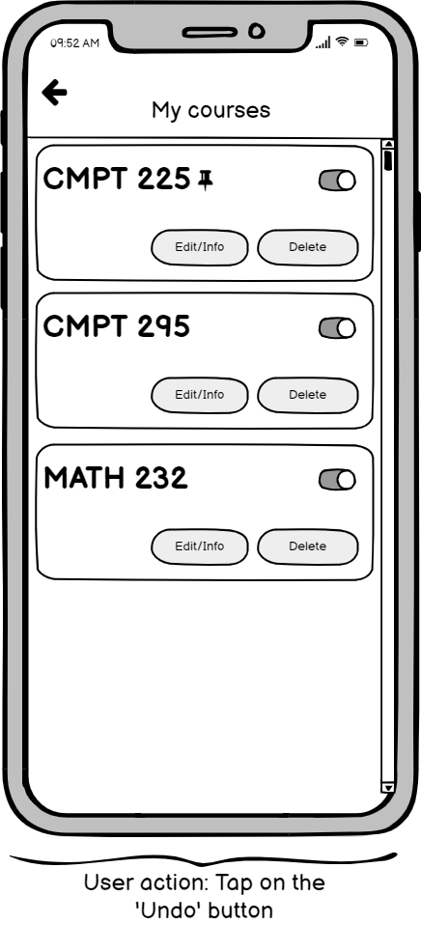

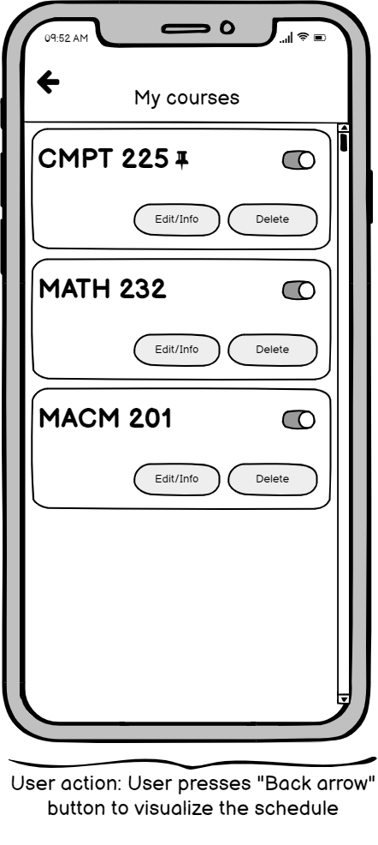

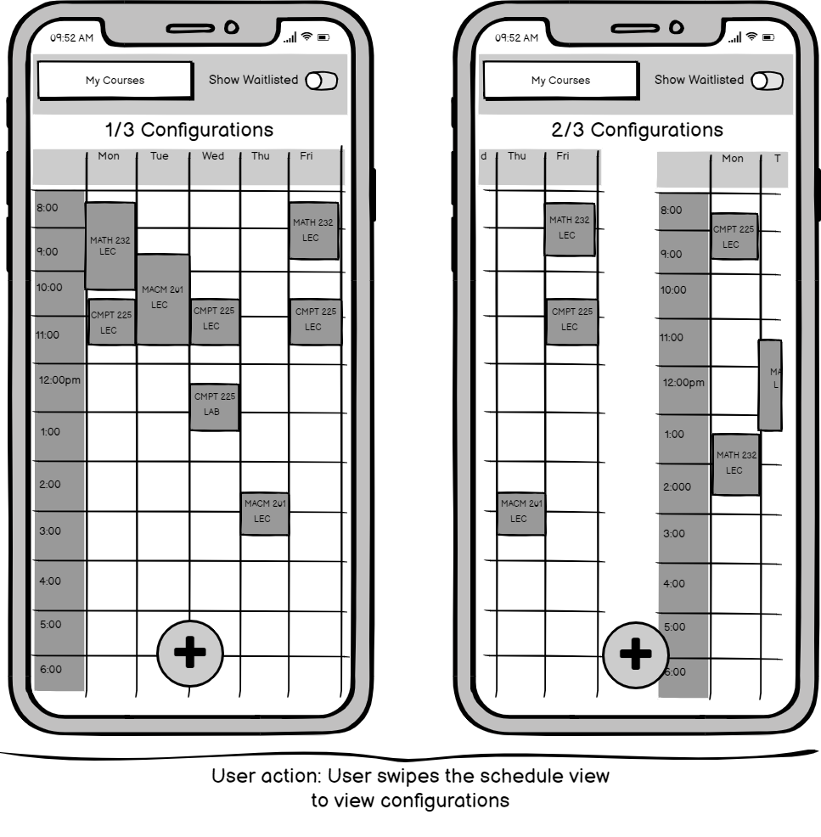

**Design Scenario #3: Change and Add courses**

George is a second year SFU student and has just received his course registration date to sign up for new classes. He decides to log into MySchedule to try and set-up his course schedule for the next semester. Going into MySchedule, he has a few things he wants to keep in mind when creating his schedule. He wants to be able to take a CMPT course on Monday, and also take a MACM course with his favourite instructor John Doe. He decides on CMPT 125 and MACM 201. As he is adding the courses, he decides he wishes to switch the time of his MACM 201 class to be later at 11:30 on Mondays.

Scenario 3 Storyboards:

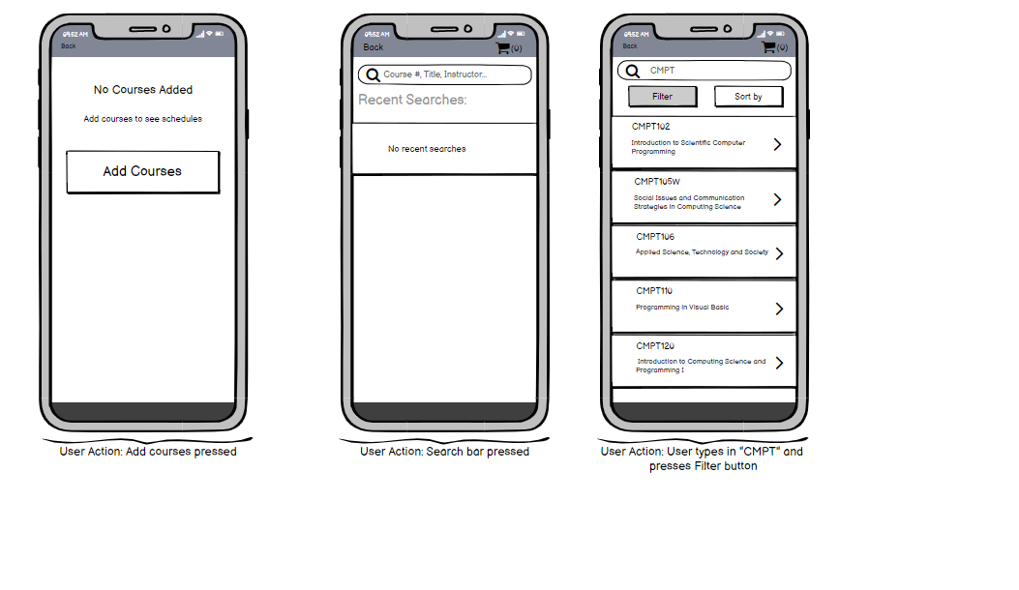

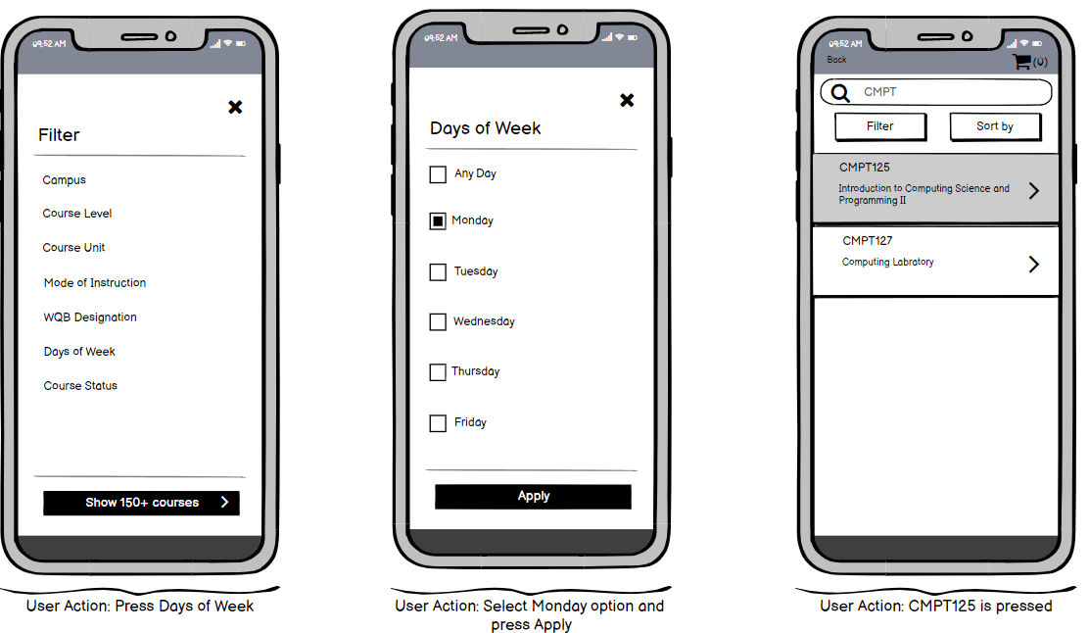

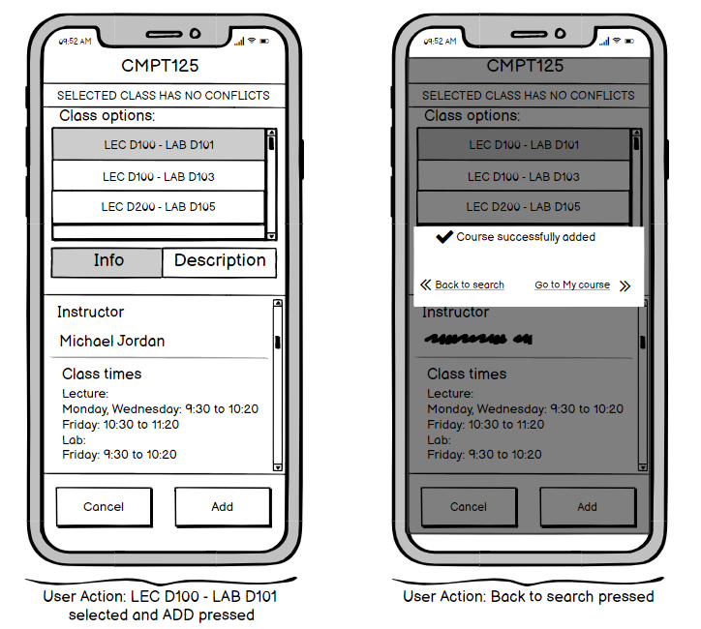

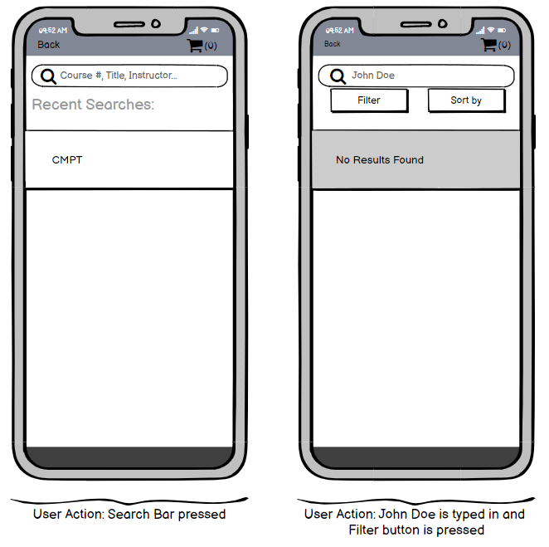

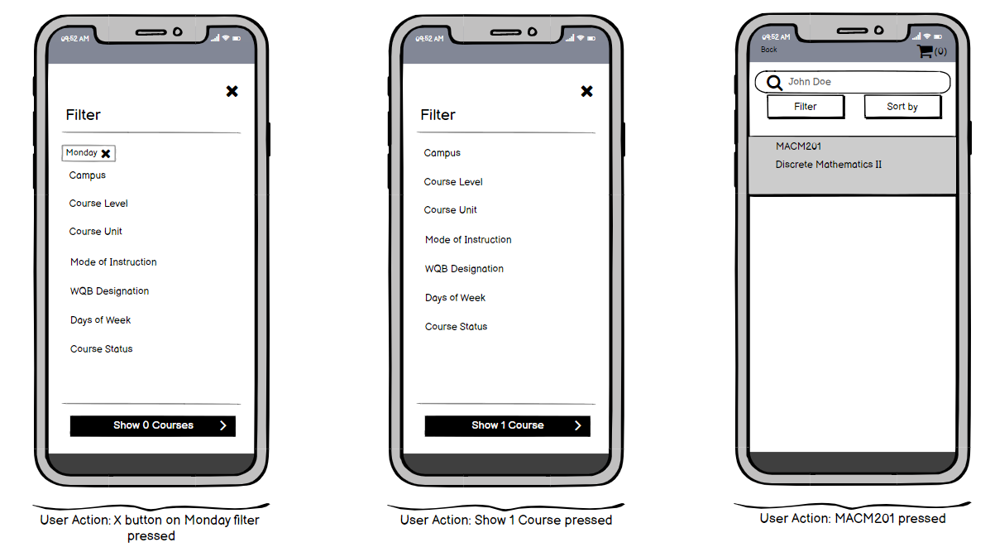

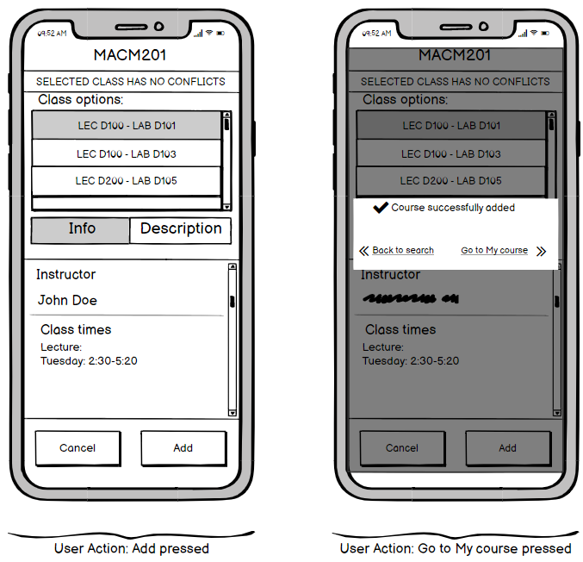

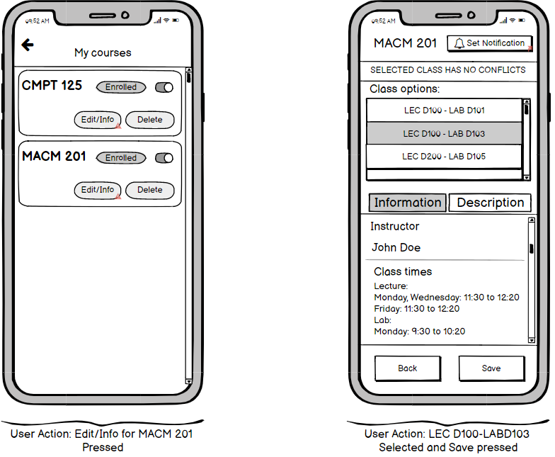

**Design Scenario #4: User wants to add notification on the course**

John plans to enroll full time in the spring semester, hence he adds 3 courses into the schedule. John does not want to miss out on any new updates regarding the courses he has selected. He wants to know any changes about a course such as extra seats addition, course seats full, course seats available etc. so that he can make an informed decision as fast as possible. To do that he uses the Notification feature to create scheduled updates for the course Macm 201. He now gets an update regarding the course’s status such as seat availability, current waitlist etc. every 4hrs

